The bending stiffness of *N*-layer laminated cylinder is

 (1)

where  and  are the internal and external radii of each layer, respectively, , as shown in figure 1,  is constant, and for each layer we have

 (2)

with

 (3)



Figure 1: Schematic of *N*-layer laminated cylinders with radius sequence {*b*n}

The bending stiffness can be rewritten as

 (4)

with coefficients

 (5)

Let , where *b0* and *bN* are the inner and outer radius of the cylinder, respectively. Then eq. (4) becomes

 (4)

Assume the laminated cylinder consists of heterogeneous layers with periodicity. For simplicity, let us first consider layers with two different materials, and the periodic arrangement of elastic properties is *Cij*-1, *Cij*-2, *Cij*-1, *Cij*-2, *Cij*-1, *Cij*-2, …

**Part I: No-friction interface**

In the case of frictionless interface, the 5*N* unknown constants (4*N* *Ki*’s and *N* *v*’s) are determined as following. The *N*-1 interfacial conditions result in 5(*N*-1) equations

 (6)

*n* = 1, 2, …, *N*-1, while the inner and outer free surface conditions yield four more equations

 (7)

With the known equation , we have 5*N* equations to solve for the 5*N* unknowns. Specially, the 4*N* unknowns  can be obtained by solving the following linear equations

 (8)

In this case,  and  are not coupled with each other and thus can be solved and analyzed by using the method similar to the homogenous layer case. Recall that eq. (4) can be rewritten as

 (9)

From eq. (8) and applying Taylor expansion of  around  gives

 (10)

where *Ci,n* (*i*=1,…,4, *n*=1,2,...,*N*) are constants for each layer (computed from Mathematica). Similarly, taking the Taylor expansion of (*II*) and (*III*) around *bn* gives

 (11)

Then eq. (9) becomes

 (12)

Since the layer arrangement is periodic, then we can rewrite eq. (12) as

 (13)

Let , we obtain *EI* as

 (14)

where

 (15)

From eq. (14) we know that the limiting effective bending stiffness  is the average of that of two materials, as shown in figure 1. We can also generalize from *k*=2 that, in the case of no friction,  of a cylinder with periodic arrangement of *k* different materials is the average of limit effective bending stiffness  of each layer.

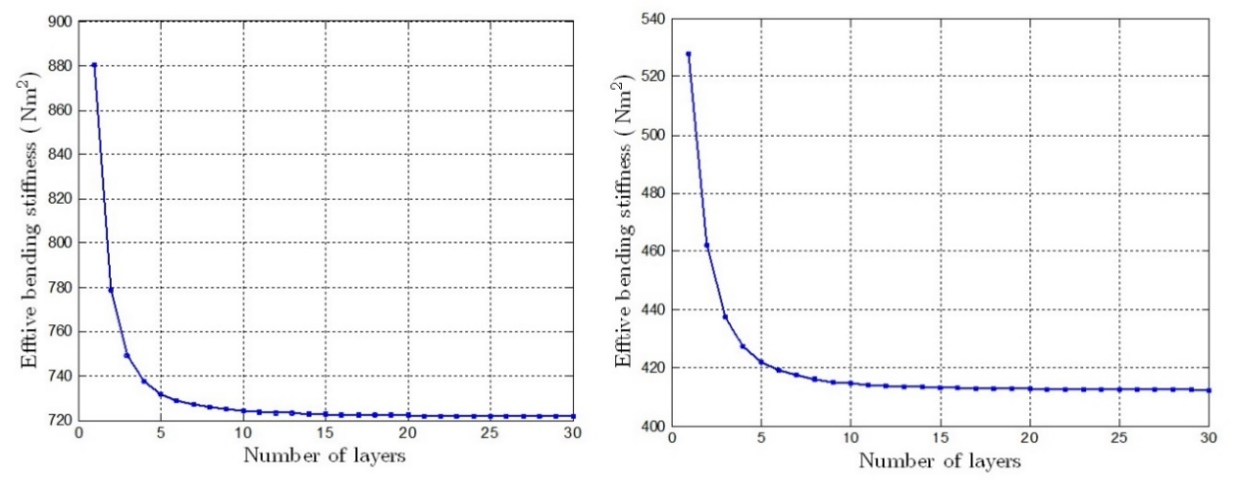

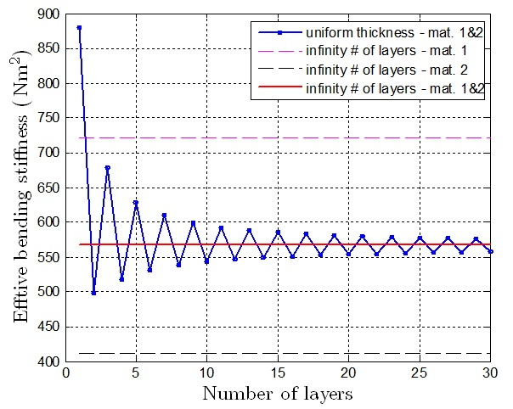

Figure 1: Effective bending stiffness with infinite number of layers

**Part II: No-slip interface**

In the case of no-slip interface, the 5*N* unknown constants (4*N* *Ki*’s and *N* *v*’s) are determined as following. At the interface, the equations for continuity of stresses and displacements are

 (16)

*n* = 1, 2, …, *N*-1, where  and  are constants and for each layer we have

 (17)

while the condition of inner and outer free surfaces yield four more equations

 (18)

By eliminating  in eq. (16), we obtain the equations for solving the 4*N* unknowns 

 (19)

where , *n* = 1, 2, …, *N*-1, and

 (20)

In this case,  and  are found to couple with each other. Let , eq. (19) becomes (*n* = 2, …, *N*)

 (21)

which can be rewritten as

 (22)

From the above equation we find that for *n* = 2, …, *N*,

 (23)

with



Then eq. (23) becomes

 (24)

which relates  and . Recall eq. (20) for boundary conditions of *n*=1 and *N*, express  in term of  with the recursive relation in eq. (24), then  can be solved from eq. (20) and  can be recursively obtained from eq. (24).

For , we postulate that the effective bending stiffness of the cylinder is equal to that of the cylinder with only one layer but the elastic constants are the average of these two materials. The reason is that we can consider the two











